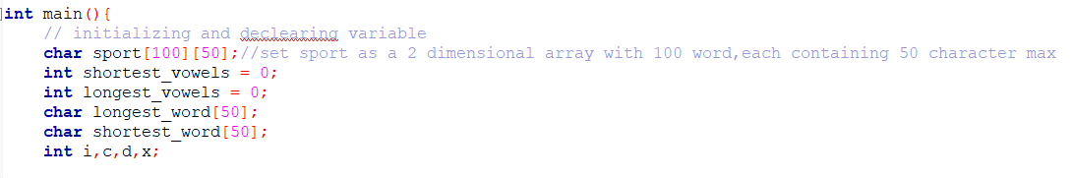

* I start off by naming and declaring the necessary variables and arrays for the code. Sport is set as a 2-dimensional character array with a 100-word limit, each containing 50 characters. Shortest vowels and longest vowels are set as integers in the vowel count holder for the longest and weakest words.

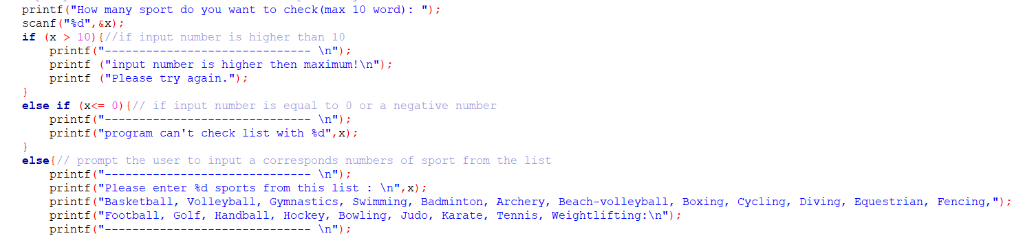

* Next, I create a print sentence to prompt the user to enter a number of sports that they want to check, with a limit of 10 words max.
* If the input number is higher than 10, it will print a warning for the user to know that the number isn’t suitable for the code.

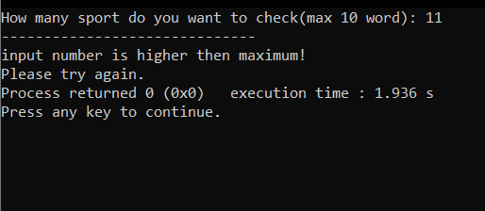

* Same output would happen if user input 0 or a negative number

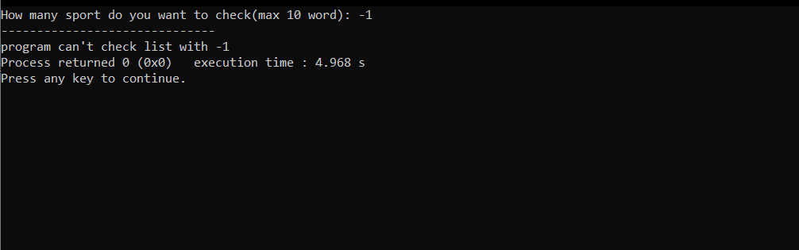

* If the user input a number smaller or equal to then 10 then the code would print out the list of sports to check from along with the inputted value.

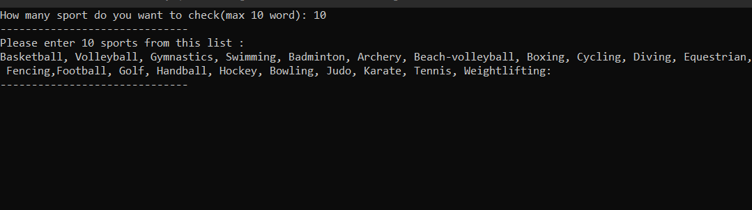

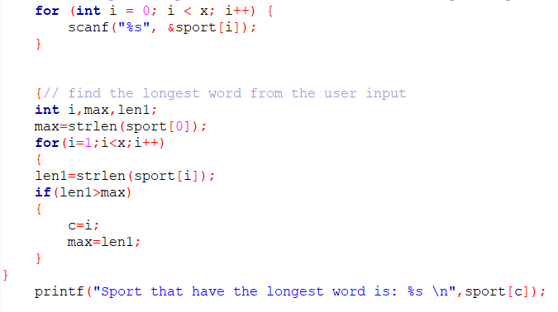

* In this step, when the user input a list of sports ( springs ) the for loop will provide stabilities which help avoid crash when input list have comma,space and new line between them.
* The new integers i, max, and len1 are declared to find the longest word in the inputted list of sports. Max is equal to strings sport[0] length, while len1 is equal to strings sport[i] length.

* This means that if len1 is higher than max, then the c array is equal to I, and max = len1, which is the highest word in the string. The code will print out the highest word from the sport[c] array. 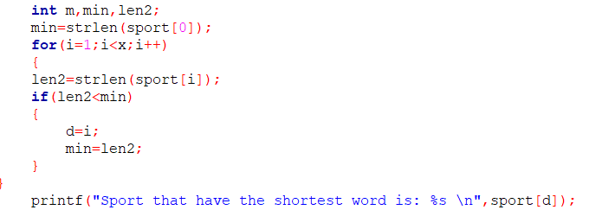
* To find the amount of vowels in the highest word we need to copy the word from sport[c] array to the character longest_word array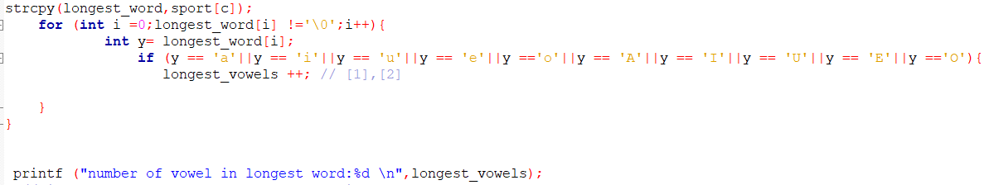
* We would then use the for loop to check to see if there are any vowels found in the longest_word array. It will increase longest_vowels by 1 each time it finds a vowel, which the print function will use to print out the number of vowels founded in the largest word.

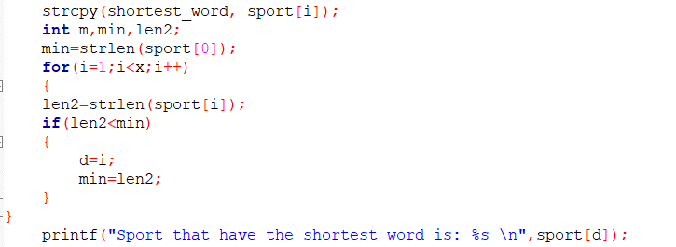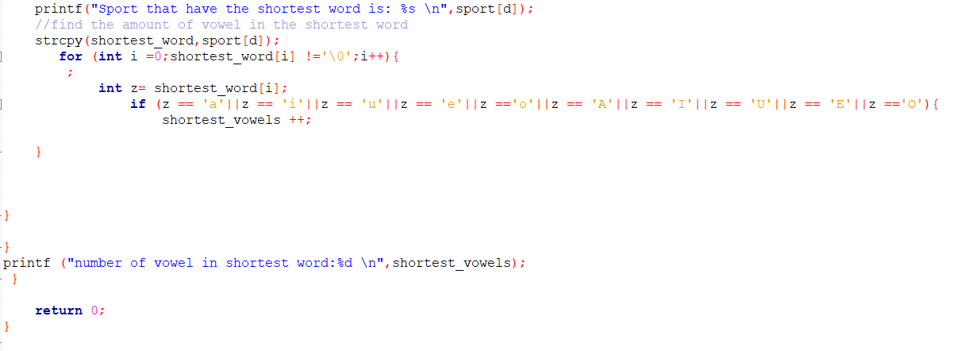

* To find the shortest word and its vowel count in the spring, we can use the same code to find We need to declare a new value and change it so that len 2 < min, which will print out the shortest value. If we keep it at len 2 > min, then it would confuse the compiler.

RESULT

